**MODULE FOR CUPOLA**

Authors: Justin Cabacungan, Alexander Tang, Nick Ribeiro

**CONTENTS**

INTRODUCTION. . . . . . . . . . . 3

QUICK FACTS. . . . . . . . . . . . . 4

IMAGES. . . . . . . . . . . . . . . . . . 6

TUTORIAL. . . . . . . . . . . . . . . . 7

REFERENCES. . . . . . . . . . . . . . 8

**INTRODUCTION**

The cupola is a small module designed for the observation of operations outside the station such as robotic activities, the approach of vehicles, and spacewalks. Its six side windows and a direct viewing window providing spectacular views of Earth and celestial objects. The windows are equipped with shutters to protect them from contamination and collisions with orbital debris or micrometeorites.

TO BE CONTINUED……

**QUICK FACTS**

* The cupola houses the robotic workstation that controls the Canadarm2.
* The cupola controls the ISS’s remote manipulator arm.
* It can accommodate two crewmembers simultaneously.
* The cupola was named after the raised observation deck on a railroad caboose.
* Provides spectacular views of Earth, and celestial objects.
* 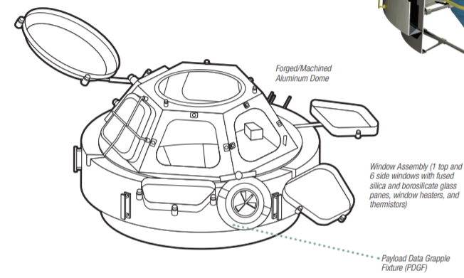Exterior design, and parts of the Cupola:

Image source: <https://www.nasa.gov/sites/default/files/atoms/files/np-2015-05-022-jsc-iss-guide-2015-update-111015-508c.pdf>

* 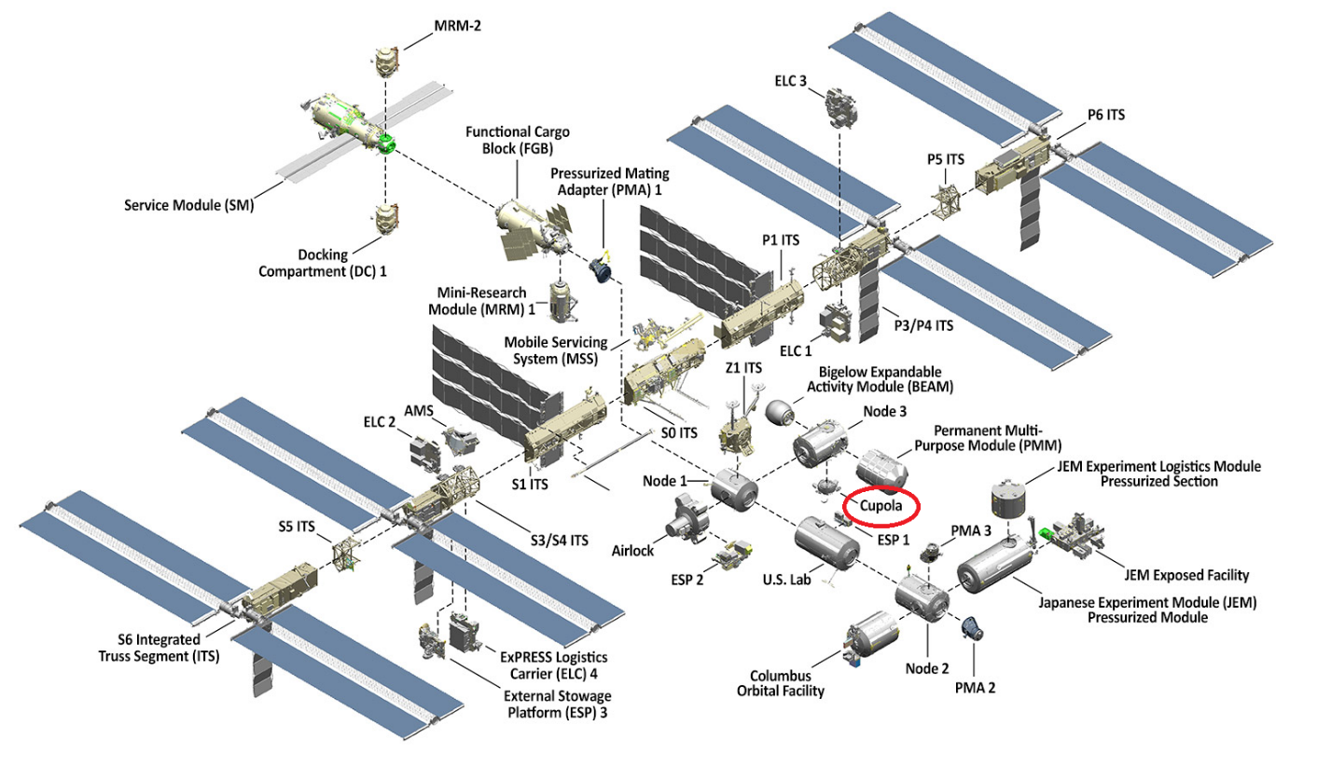Location of the cupola in the ISS (International Space Station):

Image source: <https://www.nasa.gov/feature/facts-and-figures>

* Mission Overview of Cupola

**Technical Name:** Cupola

**Launch Date:** February. 8, 2010

**Mission:** Assembling and maintaining the space station, and capturing unpiloted resupply vehicles.

**Ownership:** European Space Agency

**Built by:** MacDonald, Dettwiler, and Associates Ltd. in Brampton, Ontario

**Length:** 1.5 m (4.7 ft.)

**Maximum Diameter:** 3m (9.8 ft.)

Source: <http://www.asc-csa.gc.ca/eng/iss/canadarm2/data-sheet.asp>

**IMAGES (BLENDER)**

Images provided by: Nick Ribeiro

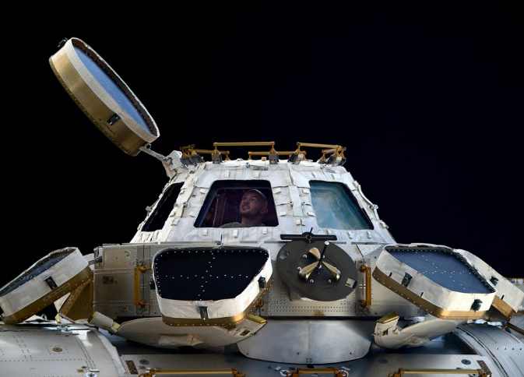

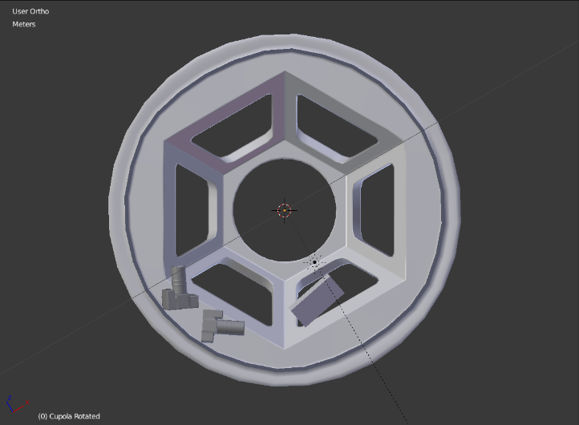

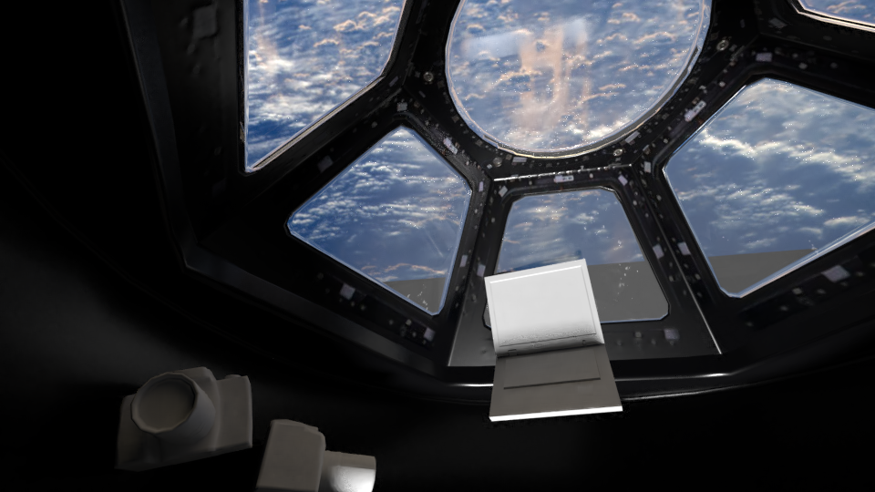

**REFERENCES**

* <https://www.nasa.gov/>
* <https://www.nasa.gov/sites/default/files/atoms/files/np-2015-05-022-jsc-iss-guide-2015-update-111015-508c.pdf>
* <https://directory.eoportal.org/web/eoportal/satellite-missions/i/iss-cupola>